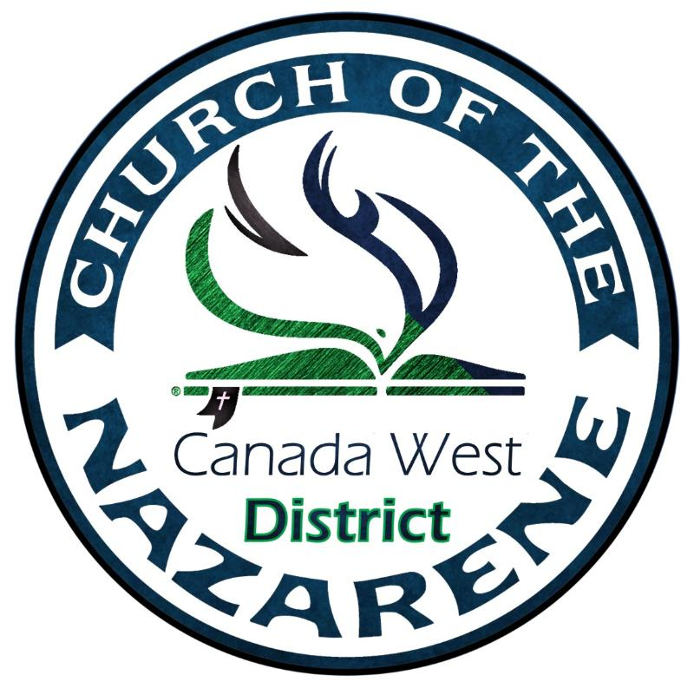
2020-21 District Calendar
January 2021
18-21: Prayer Retreat

February 2021
Alabaster Month
26-28: National Assessment Centre

March 2021
7: Camp Sunday

April 2021
4: Easter Offering
8-10: Board of Ministry

May 2021
27-29: SDMI Spark

June 2021
June 23-July 2: General Assembly

July 2020
1-4: Harmattan Grade 3&4
5-7: Harmattan Grade 1&2
8-11: Harmattan Grade 5&6
14-18: Harmattan Grade 7&8
20-25: Harmattan Teen Camp
30-Aug 1: Church Planting Essentials

August 2020
2-9: Harmattan Family Camp
(Speakers Gary Bennett & Mary Paul)
7-9: Lakeshore Family Camp

September 2020
Alabaster Month
25-26: SNAZ Party

October 2020
11: Thanksgiving Offering
16-18: Soul Care

November 2020
8: Helping Hands Sunday

December 2020
11: Thanksgiving Offering
16-18: Soul Care

Weekly Pastors Prayer Meeting: Every Wednesday at 1:00 PM (Mountain Time)
Pastors Affinity Group Meeting: 1st Tuesday, Wednesday & Thursday of every month
District Assembly (Reunion) 2021: July 29-31

